Battle Creek Transit

ADA COMPLAINT POLICY

Prepared by:
Kristy Grestini, Mobility Manager
Mallory Avis, Public Transit Director

Effective Date: June 15, 2023

Adopted by: Battle Creek City Commission Date Adopted: June 20, 2023

Table of Contents
1 Purpose 3
2 Policy 3
3 Making a Complaint 3
4 Processing of a Complaint 3
5 Notification of Complaint Process and Rights Under The Americans With Disabilities Act 4

- Purpose

To establish a policy regarding the processing of discrimination based complaints received by Battle Creek Transit (BCT) pursuant to the Americans with Disabilities Act of 1990 (ADA) regarding its public transportation operations.

- Policy
The ADA provides that no entity shall discriminate against an individual with a disability in connection with the provision of transportation services. The law sets forth specific requirements for both vehicle and facility accessibility and the provision of services. BCT is committed to providing safe and reliable public transportation services to all people without discrimination based on disabilities.
- Making a Complaint
When making a complaint, the complainant shall provide in writing the following information:
- Name, address, telephone number;
- If known, the name of the person that complainant believes has committed the discrimination;
- A brief description of the acts of discrimination;
- The dates it is believed the discrimination occurred;
- Other information that complainant believes necessary to support their complaint;
- Information on how to best communicate with the complainant including any required materials such as large print, braille, etc.
Attachment A is intended to guide the complainant in submitting a complaint.
- Processing of a Complaint
If BCT receives a complaint regarding discrimination against an individual pursuant to the ADA who is seeking, or has sought, public transportation services, BCT will respond within 30 days of receiving the complaint and will work to resolve the complaint as quickly as possible. All aspects of the resolution process will be documented and, upon resolution, will share with the Michigan Department of Transportation and Federal Transit Administration details of the complaint and the associated resolution. Complaint related documentation will be retained by BCT for a minimum of one year. A summary of all complaints will be kept for five years with records being made available for inspection upon request.
When a complaint is received, BCT may take any or all of the following actions:
- Contact the complainant for additional information or copies of relevant documents;
- Work with the complainant to resolve the issue;
- Refer the complainant for possible action through an ADA mediation program;
- Refer the complainant to another federal agency with responsibility for resolving the types of issues that may be raised;

A complainant may check the status of their complaint by contacting the Battle Creek Transit office.
- Notification of Complaint Process and Rights Under The Americans With Disabilities Act
Attachment B will be posted in all BCT vehicles, at BCT administrative offices, and at the Battle Creek Transit bus transfer center.

Attachment A

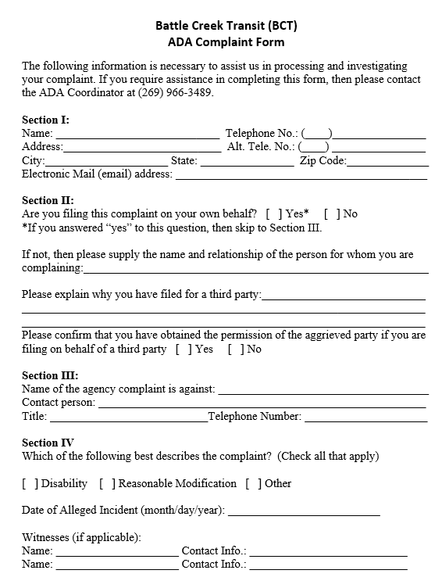

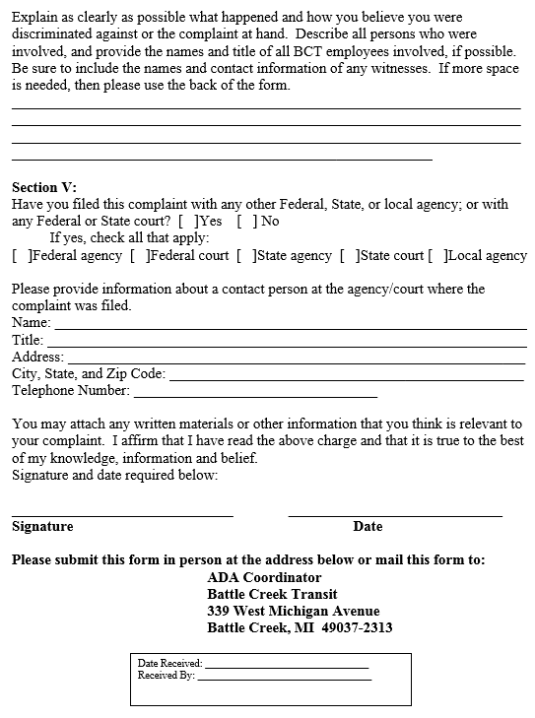
Attachment B

Public Notice of Rights Under The Americans With Disabilities Act
Battle Creek Transit

- In accordance with the requirement of Title II of the Americans with Disabilities Act of 1990 (ADA), Battle Creek Transit (BCT) will not discriminate against qualified individuals with disabilities on the basis of disability in its services, programs, or activities.

- BCT provides reasonable modifications for individuals with disabilities by making changes to policies, practices, or procedures to ensure that people with disabilities have an equal opportunity to enjoy all programs, services, and activities.

- Complaints that a program, service or activity of Battle Creek Transit is not accessible to persons with disabilities should be directed to BCT’s ADA Coordinator, Kristy Grestini at 269-966-3489; email to klgrestini@battlecreekmi.gov; or visit our administrative office at 339 W Michigan Avenue, Battle Creek, MI 49037.

- For more information on the Americans with Disabilities Act, visit our website at http://www.battlecreekmi.gov/transit

- To request this document or information in another language please call (269) 966-3474.

- Para solicitar este document o informacion en otro idioma, por favor llame (269) 966-3474.

